DEVELOP A SALES LEADER WITHIN YOUR ADMIN
With Miranda Martin, Jamie Irvin & Summer Gee
“Communication is the glue that holds the Agency together”

- MAKE SURE AGENCY IS ON TRACK FOR PROMOTIONS:
Do you have the Issue Rate & Writers?
BUSINESS FOLLOW UP
- Business Follow Up for Issue Rate – Minimum 75% and how to maintain that standard monthly
- Monday, Wednesday, Friday: 1-2 Hours per day following up with carriers

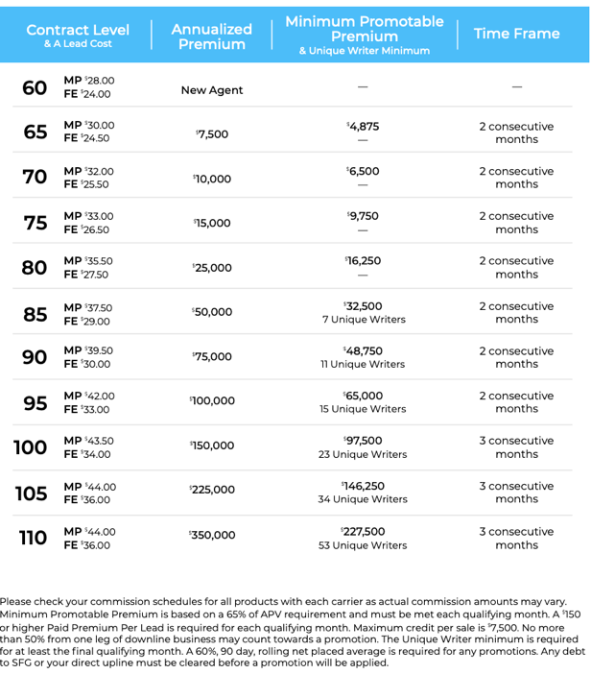

ADMIN CAN TRACK AND CHEERLEAD TO MAKE SURE AGENCY IS HITTING THESE TARGETS
Contract Level | APV | Appts Per Week | Interviews Per Week | Packets Back | Conference Tickets Sold
75% | $30,000 | 25-30 | 15 | 1-2 | 7-8
85% | $50,000 | 35-40 | 25 | 3 | 10-15
90% | $75,000 | 50-75 | 50 | 5 | 15-20
95% | $100,000 | 75-100 | 75 | 7 | 20-25
100% | $150,000 | 100-150 | 100 | 10 | 30-40
105% | $225,000 | 150-200 | 150 | 15 | 50-60
110% | $350,000 | 250-300 | 200 | 20 | 70-80

- TRACKING APPTS Targets & Breakdown (Weekly Tracking of dialing totals)

- AGENCY BUILDING:
Is agency getting enough interviews each week & packets back?

  - Admin Setting 25 interviews per week as a standard (Script Included)
  - Admin hiring and training recruiters and teaching agents how to recruit
  - Self-Booking Script (Attached)
  - Creating a Building Culture within your team

Self Booking Script. –Real Nadeau Agency
Hi can I speak to (Candidate) please?

Hi (Candidate) my name is Veronique, I’m the hiring manager at Symmetry Financial Group, how are you today?
I’m calling because you recently applied to the position that we have up on Zip Recruiter, I was just looking at your resume - which is why I’m calling - I wanted to see if we could get you scheduled for an interview.

I have availability on Thursday morning at 9am for a phone interview, would that work for you? Ok, great!

(Candidate) before the interview there are a couple videos that I’m going to ask that you watch. They do a really great job of laying the ground work for the conversation we're going to have on Thursday, so they talk about the position and what it entails, more about who we are as a company - because it’s important for you to get to know us a little bit better too right? They also give you more details on the compensation and the opportunities for growth with this position. Let me make sure that I’m sending that to the right email address, the one I have here is is that correct? Ok, great!

So I’m going to go ahead and send that over to you, now you’ll see that my email is going to have two links in there, the first is a 5-minute short introduction, and a 20-minute more detailed overview. And that 20-minute video, that’s really where you’ll get the bulk of the information that we’re going to be discussing on Thursday. What I recommend, because there’s so much information in that one, is to watch it with a notepad next to you - just so that way you can jot down any notes or questions that come up along the way.

Ok, I’m going to go ahead and email both of those links over to you within the next couple of minutes, and I’m also going to include the time of your interview on Thursday, that way you have everything you need all in one place.

So I’ll reach out to you for your interview on Thursday at 9am, if you have any questions before then, please feel free to let me know!
Thanks, and have a great rest of your day!
- CONF REG – **MOST CRITICAL FOR GROWTH**
  - Posture of the conversation between Admin and Agents (Script Included)
  - Track conference registrations and promotion
  - Weekly Countdown/Goal Sharing – 3-5 Per week
Conference Conversation
Hi (Name)?

Hey (name) this is Jamie with Symmetry Financial Group/Martin Agency, how are you?

I wanted to touch base with you now that you are part of the team!
**If you’ve never spoken to this agent, take the time to get to know them and build rapport**

I wanted to talk to you about Conference. I know that (upline) has spoken to you about it previously so I wanted to hit the done button on this for you while we still have some discounted tickets available. All of our agents go twice a year to learn and associate. Our next conference is going to be (date) at (location) so that will give you plenty of time to get everything in order. Do you have a registration ticket or do you need me to email you one?

If YES - - okay great – lets get that filled out and sent back today, it’s not too late for payment plans so when you get it back to me we can work on that together. Everyone will be there so you will have an opportunity to meet our master agency owner Miranda Martin as well as (your agency owner). Its where we all go twice a year to learn how to make that next level of income I was telling you about during our interview.

If NO - - Okay no problem! I will email it to you right now (or guide them to the website to download it) lets get that filled out and sent back today, it’s not too late for payment plans so when you get it back to me we can work on that together. Everyone will be there so you will have an opportunity to meet our master agency owner Miranda Martin as well as (your agency owner). We all go twice a year to learn how to make that next level of income I was telling you about during our interview!

**I want to make some money first**
I totally get that (name) trust me, when I first started the only thing on my mind was making money. My upline told me when I started that was the reason why I couldn’t’ miss this. We can teach you how to make the phone calls, set up your week and what to say in the home but conference is where you’re going to really learn how to be successful with symmetry. I know it sounds crazy but you’ll actually see normal, average people making multiple six figures in their first years with this company! The even crazier thing is they learned how to make doctor level income by taking a 40 hour course and by coming to our conferences twice a year (laugh) So no matter what we’re going to make sure you’re going, we just need to get the commitment now and we’ll work together on the on the details closer to the date.

MOST CRITICAL MINDSET:
“Communication is the glue that holds the Agency together”

Communication between Admin/Agents & Admin/Agency Owner
- Intentional warm touches with agents in your agency – at least 5 warm touches per day (sometimes more – Summer hits 20 per day_
- Relationships between Admin and Agency Owner - at least 3-5 touches per day between text/calls
- Empowering your “Business Partner”
WHO TO HIRE:
- Fast typing, typing test 35-50 WPM
- watched the videos and are excited about THIS/Passionate
- Taking notes while interview
- Personal development advocate
- Personable (friendly and outgoing to talk to agents, good sounding voice)
- Interested in a growth position. They understand if the agency grows, they grow and so does their income (perhaps part time to full time)
- “Sales minded” but not so much they want to be a salesperson
- Flexible schedule
- Ability to multi task and be open to role changing based on where the agency is
Interview process
- Typingtest.com
- Work for one day in the office before hiring (use it as a second interview to see how you work together).
Sample Ad
