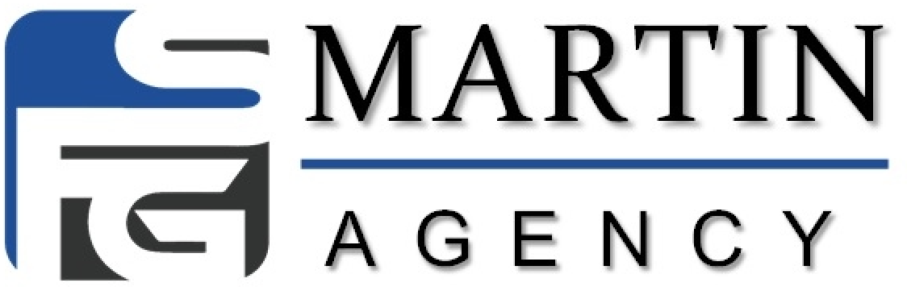

Administrative Staff Priorities and Objectives

Top 3 Objectives

    - Manager Production & Issue Rate
      - This is where Manager gets most usable income in the beginning.
      - Issued business = paid business following up is key!
      - Assist with input of apps, congrats calls and follow up.

    - Agency Health
- Conference Registrations
  - 2-3 Conf Tickets per week
- Recruiting (Packets back & Interviews)
  - Min 50 per week
  - Min 3-5 Packets Per Week
  - Recruiting part 2- Set 25 interviews per week

    - Forward Momentum/Agency hitting next raise qualifications
- Team Overall Issue Rate – follow up calls/help agents figure out their pending requirements
- Enough Leads Purchased per week per agent (part time 25-30; Full time 40-50)
- Dialer Leaderboard update to stay on track

Daily Checklist:
- Reply to all emails/pings in Basecamp
- Recruiting Clicks w/ notes in Basecamp when complete (note any issues)
- Scrub Applications twice a day Mon-Thur and then three times on Friday
- Check Recruiting Board that interviews are allocated for the day
- Look in OPT for leads for agents who need leads
- Help agents as needed, making notes of conversations in Basecamp for manager and upline to see.
- 911/411 Assistance
- Look at click rate in get response to make sure that we are getting good results
- Congratulatory messages on Groupme for Production and Conference Reg.
- Count down to goals.
- Check in daily with On-boarded agents to see if they are on-track or have any questions (make notes in BC)
- Set 25 Interviews for Agency with target back of 12 Answer, 6 Packets out, 3 Back per week, 1-2 conf tickets.
- Add Packet Sent applicants to the 2018 New Recruit Sheet
- Conference Call Reminders in Groupme

Weekly Checklist:
- Targets – MIN 50 Interviews Weekly – 5 Packets Back – 2-3 Conf Tickets
- Production Target (Based on current contract level)
- Set weekly goals for the team based on what is needed to hit monthly goal!
- Application scrubbing – Sunday 12PM EST all revisions from previous week must be approved

Monthly Checklist:
- Work with agents at the end of the month to focus on their issue and help them get policies pushed through
- Promotion Request forms submitted to corp. for all agents in hierarchy (cc Jamie, Michelle Miller, Miranda, Agency Manager & Upline)
- Raise request forms submitted to corp. (cc same as above)
- Circulate Snap Shot Report to your team
- Make sure agents are registered for conference and registering their downlines
- Last Friday of month, scrubbing as late as necessary – Sunday 12 EST all revisions must be approved to count for the month

Monday: - Master Mind Day!
- Recruiting Clicks w/ Notes in Basecamp
- Remind previous week’s onboarders about 10:30am ZOOM w/ Miranda
- Place or Refresh Recruiting Ads
- Recruiting Stats (How many interviews; how many from which sources?) by 9AM EST
- Noon EST – Admin Weekly Call w/Miranda
- Double check that recruiting is set up properly (landing pg, Calendly, etc)
- Check in with any current on-boarders (Day 2 – make sure they know where to get the homework)
- -New Producer Packets sent to corp (by Wednesday latest)
  - Make sure ALL have Conference Ticket Processed
- Start prepping for who will start on-boarding next week.
- Set 6 outbound Interviews

Tuesday: Recruiting Day!
- Recruiting Clicks w/ Notes in Basecamp
- Enter Any Apps from the Manager in OPT. (Scrub prior to entry)
- Send Lead Reminders to Agents.
- Send email and/or text invite to “non-packet returners” to the cc Wed and Friday
- Check in with any current on-boarders (Keys to Success/business plan tonight)
- Ensure Agency will hit interview target/ Make first interview calls to fill up schedule (goal 25 each) – share target/current status
- If we haven’t got confirmation that GMR’s have been processed, double check with corporate on them – leads@sfglife.com
- Send email follow up to people that hadn’t sent packets back
- Send follow up to those that have sent packet back but haven’t registered for school yet
- Set 7 outbound interviews

WEDNESDAY: Allocation Day!
- Recruiting Clicks w/ Notes in Basecamp
- Enter applications from Agency Owner in OPT
- Lead Allocation
  - Make sure all new GMR people are showing on the Allocation Sheet
  - Text each person and let them know what they have. Look in opt if we have extras for them.
  - If theres more leads on the emailed sheet than in OPT email Maitland – mdemos@sfglife.com
- Outbound calls to active Agents to check in (Notes in BC)
- Onboarders for this weekend due today. Make sure packet gets to corp and conf ticket is processed.
- Check in with any current on-boarders (In Home Part 1 tonight)
- Set 6 outbound interviews
- Leaderboards for Weekly Production for the Team (Master Admin)
  - Track where agents are monthly for promotions, encourage them. (Agency Admin)
  - Conference updates with leaderboards, also share in your groups

THURSDAY: Issue Business Day!
- Enter any more applications from Agency Owner in OPT
- Send email and/or text to agents who haven’t bought leads.
- Follow up on outstanding business – Call all Carriers
- Pending Requirements – send them to agents and help them with issue rate (cc manager)
- Check in with any current on-boarders (final day – In Home P2)
- Check with newer agents on getting E&O for other carriers
- Send email follow up to people that hadn’t sent packets back
- Set 6 Outbound Interviews

FRIDAY: Rally for DIAL DAY!
- Start Live Dialer and track appointment as they are scheduled
  - TEAM TARGETS
    - 50K AGENCY - 35-40 APPTS PER WEEK
    - 75K AGENCY – 50-75 APPTS PER WEEK
    - 100K AGENCY – 75-100 APPTS PER WEEK
- Rally Team around Team and Individual Goals
- Make sure any uplines know who is going in on-boarding this week and ensure they talk to them (Text and note in BC)
- MAKE SURE ON-BOARDER UNDERSTANDS THE EXPECTATIONS FOR THIS WEEK (Note in BC)
- Follow up on outstanding business you didn’t get to on Thursday– Call Carriers
- Pending Requirements – send them to agents and help them with issue rate (cc manager)
- Outbound calls to Duck Pond Agents. (Make notes in BC)
- (If Applicable) Handle Persona/Business Bills for Agency Owner.
- Email onboarders Reserved email (Master Admin) copy admins, managers, uplines

